Okta Account Creation and Password Reset Procedure
This document is designed to walk you through the following Okta login processes:
- Creating a new Okta account as a first-time user.
- Selecting a security question and a security image.
- Resetting your forgotten Okta password.
Begin by entering to the following website address into your internet browser search bar: login.mt.gov, or by clicking the following link: login.mt.gov. You will be directed to Okta sign-in page.

Creating a New Okta Account as a First-Time User
To create an Okta account as a first-time user, click the Sign up link to begin the process.
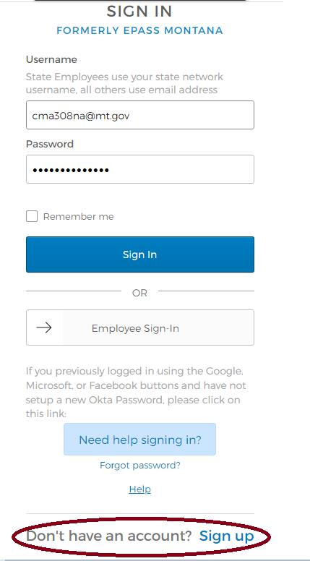

Enter your email address, create a new password for your Okta account, enter your first and last name, and click the Register button.
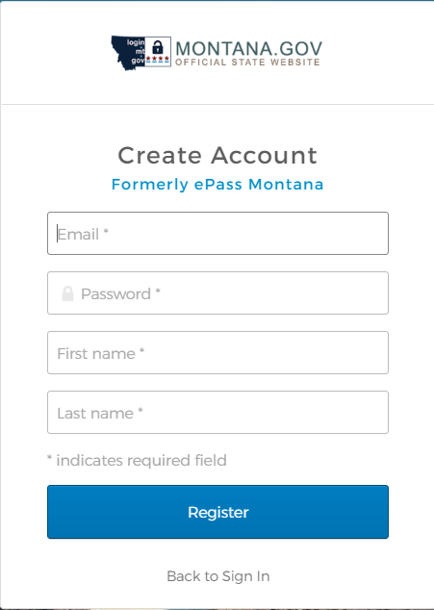

You will see the following verification message.
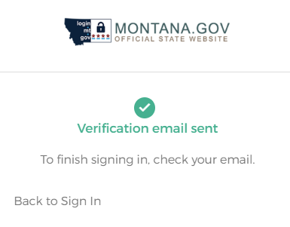

Check your email account for an Okta activation email.

To begin the Okta account activation process, click the Activate Account button.
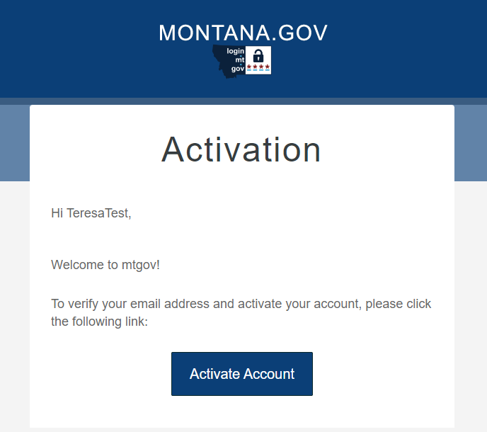

Complete the sign-in process by entering your email address and password.
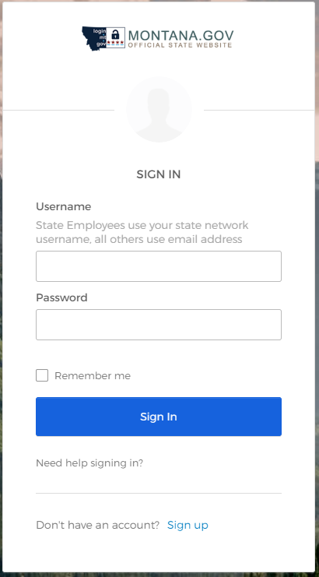

IMPORTANT NOTE: The next time you sign-in to Okta, you will be required to select both a security question and a security image. We recommend signing out immediately after your first successful login and repeating the login process to receive the prompt to select your security question and security image.

Selecting a Security Question and Security Image
Select your security question from the drop-down menu. Provide an answer to the security question. Select a security image and click the Create My Account button.
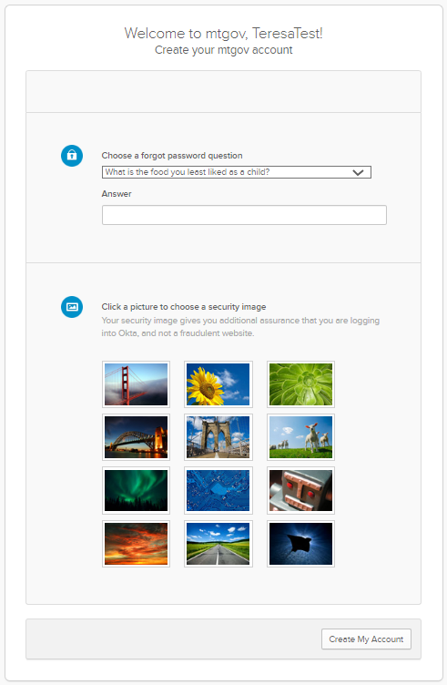

Resetting Your Forgotten Okta Password
This document is designed to walk you through the process to reset your Okta password. Begin at the Okta sign-in page for login.mt.gov, or by clicking the following link: login.mt.gov.
Click the Need help signing in? link.
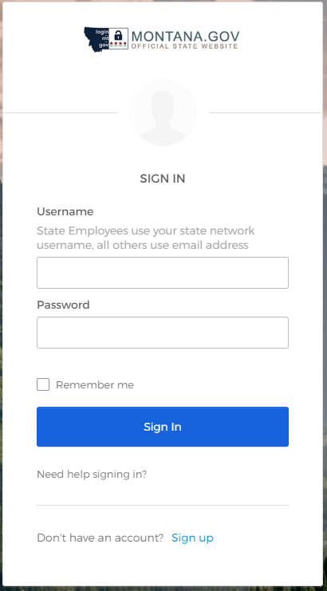
After selecting the “Need help signing in” link, you should see the “Forgot password” option.
Click the Forgot password link.
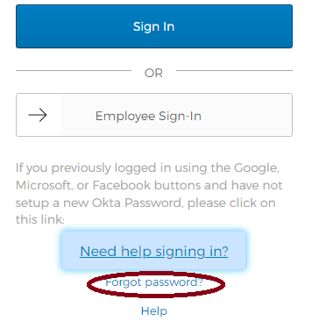
Enter your email address or username then click the Reset via Email.
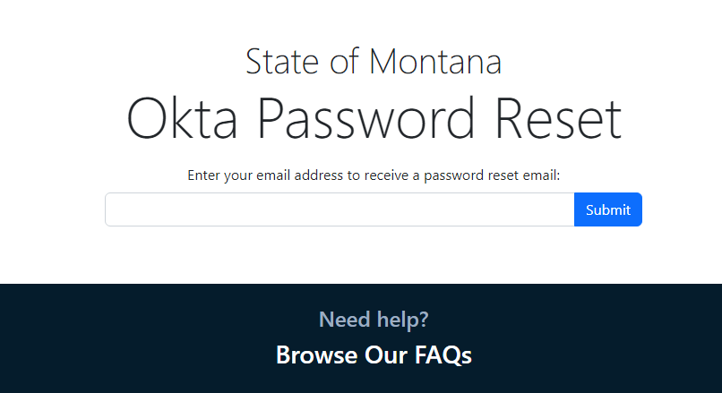
After pressing submit, you will receive a confirmation that an email from Okta has been sent to you. This email will contain the next steps for resetting your password.
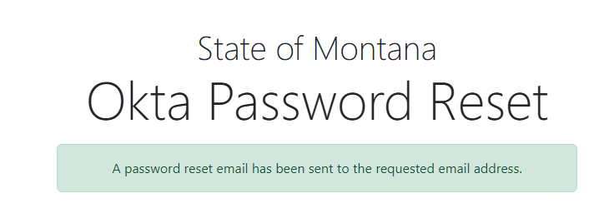
Check your email for an email from Okta.

When you open the email from Okta, it will contain one of the following confirmation messages based on if you have already selected your security question and security image.
- If you have selected a security question and security image, follow Option 1.
- If you have NOT selected a security question and security image, follow Option 2.

Option 1 – You Have Selected a Security Question and Security Image
If you have selected a security question and security image, you will receive the message below.
Select the Reset Password button.
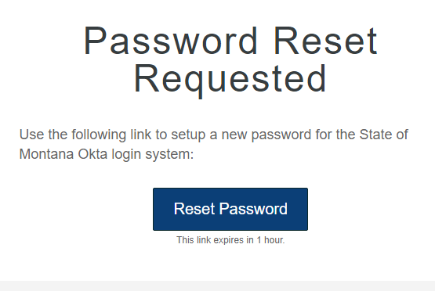

After selecting the Reset Password button, you will be prompted to answer the security question you previously selected. Enter the answer to your security question and select the Reset Password button.
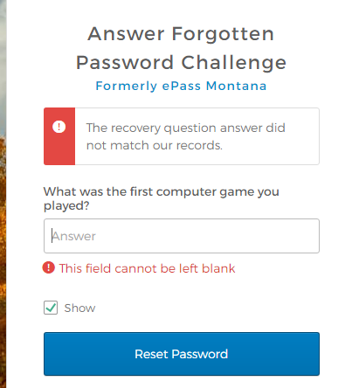
Your security question will appear here

After you successfully answer your security question, you will be prompted to enter a new password.
Enter your new password. Select the Reset Password button.
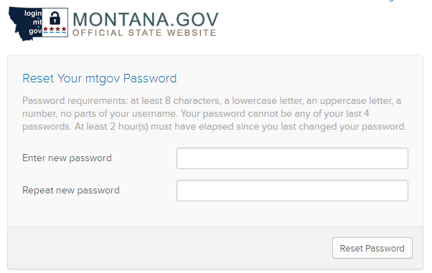

Option 2 – You Have NOT Selected a Security Question and Security Image
If you have NOT selected a security question and security image, you will receive the message below.
Select the Sign-in Help button.
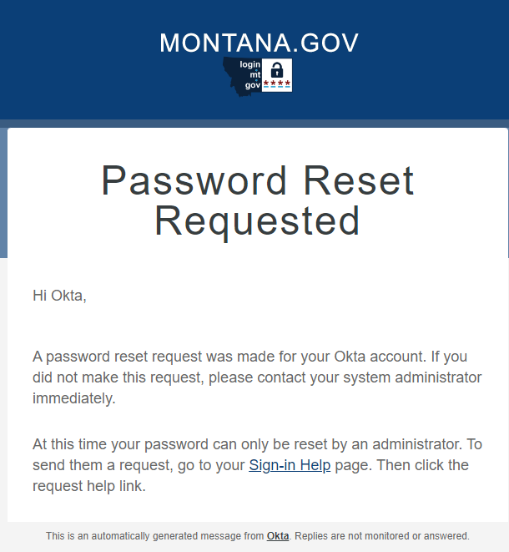

Next you will be taken to the login.mt.gov FAQs website.
Select the here button to find the corresponding agency contact information.
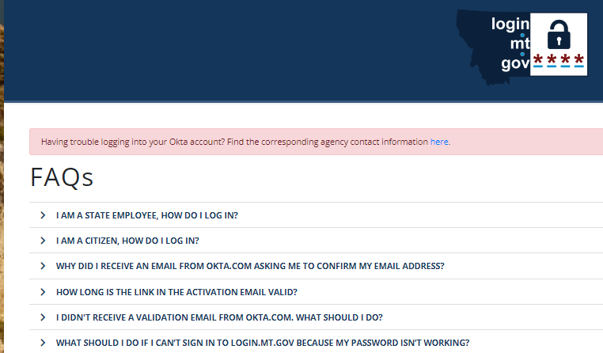
After selecting the here button, you will have the ability click on the name of the agency you need to connect with. The agency’s helpdesk email address and telephone number will display. You can either select the email address or call the support telephone number. An administrator from that agency will assist you as applicable.
